The first data set that we'll condense is class_size. The first few rows of class_size look like this:

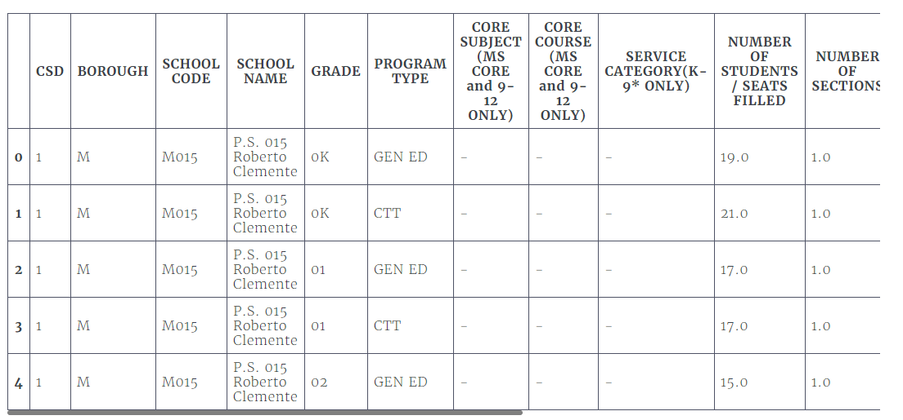

As you can see, the first few rows all pertain to the same school, which is why the DBN appears more than once. It looks like each school has multiple values for GRADE, PROGRAM TYPE, CORE SUBJECT (MS CORE and 9-12 ONLY), and CORE COURSE (MS CORE and 9-12 ONLY).

If we look at the unique values for GRADE, we get the following:



array(['0K', '01', '02', '03', '04', '05', '0K-09', nan, '06', '07', '08',

      'MS Core', '09-12', '09'], dtype=object)

Because we're dealing with high schools, we're only concerned with grades 9 through 12. That means we only want to pick rows where the value in the GRADE column is 09-12.

If we look at the unique values for PROGRAM TYPE, we get the following:



array(['GEN ED', 'CTT', 'SPEC ED', nan, 'G&T'], dtype=object)

Each school can have multiple program types. Because GEN ED is the largest category by far, let's only select rows where PROGRAM TYPE is GEN ED.